Hornby St. Margaret’s Church of England Primary
Summer 2 Planning (Years 1/2)

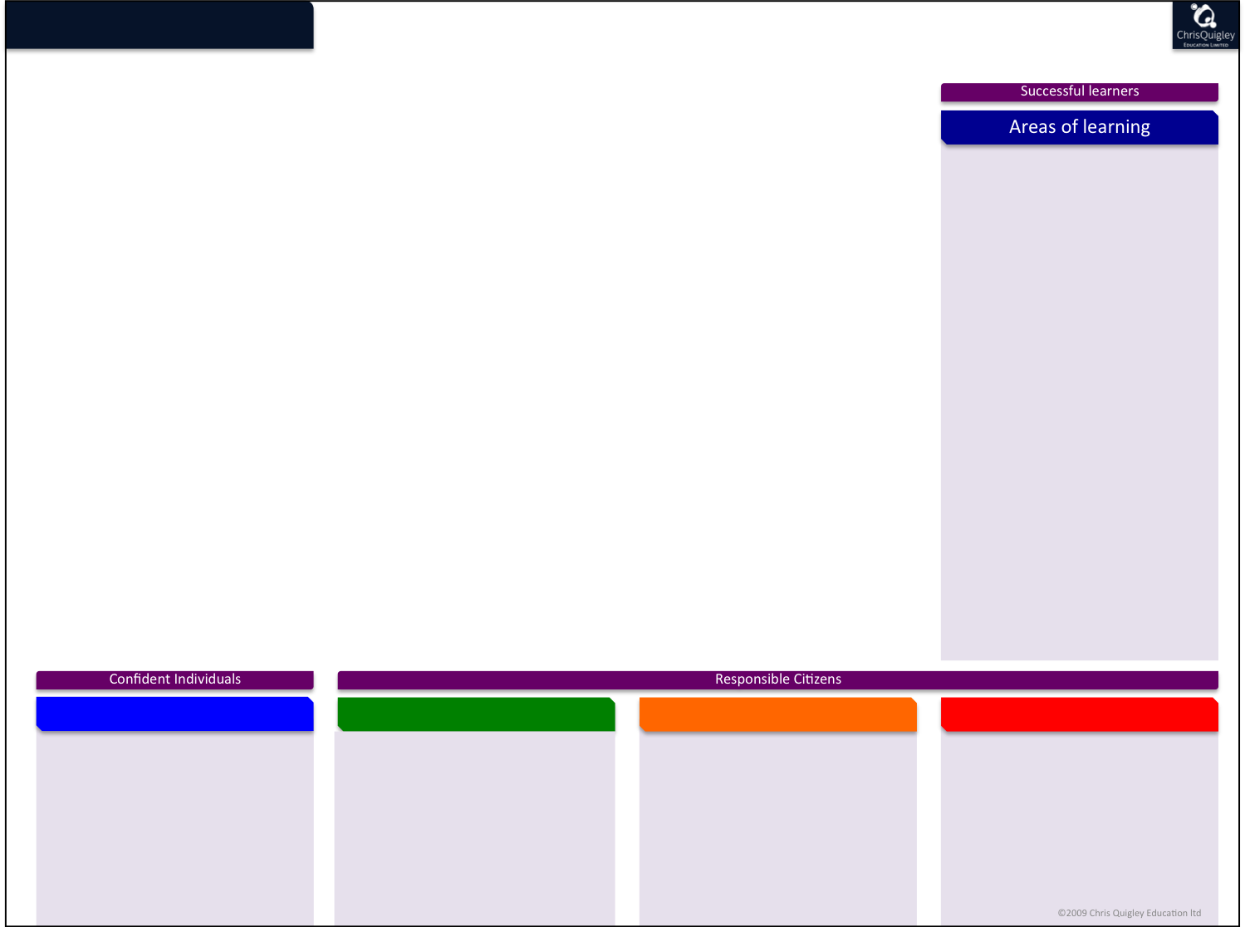
Let’s Explore
clothe

(

As Scientists we will conduct a minibeast safari on our school grounds, exploring different habitats and making a ‘choice chamber’. We will design our own minibeast and say how it could adapt to its environment. We will explore animals that live in different habitats around the world and create pictorial food chains.
As Geographers (continuing from last half term’s exploration of St George’s Day and the Platinum Jubilee) we will zoom in on the other 3 countries that make up the UK, celebrate some national events and make an Exploring the UK information leaflet. We will also learn about the oceans of the world.
As Historians we will continue to explore why Mary Anning is famous and why she was left out of some history books. We will write a letter to persuade Lyme Regis council to make a statue of Mary. We will compare the explorations of Christopher Columbus with Neil Armstong.
As Artists we will explore weaving techniques. We will create our own woven sea creatures and seascapes to use as Father’s Day Cards.
As Technologists we will explore mechanisms in vehicles and build up to designing and making our own explorers Jeeps.
As computing experts, we will continue to use Scratch to create our own computer program, directing our Sprite around.
In PSHE we will focus on transition, growing and change as well as Following a Digital Trail (E Safety)
In RE We will explore The Bible and what it means to Christians. We will also find out about other Holy Books.

Key Skills across the Curriculum
Taking Responsibility
Christian and British Values
Communities
We will explore: Reading ‘Aladdin – exploring fantasy settings
Writing diaries an persuasive letters in History
Sequencing events chronologically in Mary Anning’s life and on our class timeline.
Counting and classifying minibeasts
Measuring materials to make our explorer jeeps

Cr

As members of a community we will explore:
Local - Will consider the well being of minibeasts and animals in our community and how their habitats can be protected. Where fossils are found locally. Transition days in our school
National – Features and celebrations of the four countries of the UK.
Global – We will make our own Salvadorian cross (Forgiveness) Global explorers and global impact
In our Spiritual and Moral development we will explore:
Our class Christian Value – Forgiveness – Looking at the Easter events and story of Zacchaeus.
The Holy Bible and Holy Books of other faiths (mutual respect)
Discuss the importance of being Steward of the Earth. Looking after habitats in our local environment.
Learning about the four saints that are patrons of the four countries of the UK.

We will:
Take responsibility for using classroom equipment to help us with our learning
Take responsibility for working independently for short periods of time
Take responsibility for joining in with whole class sessions – suggesting ideas and listening/responding to others.

AH
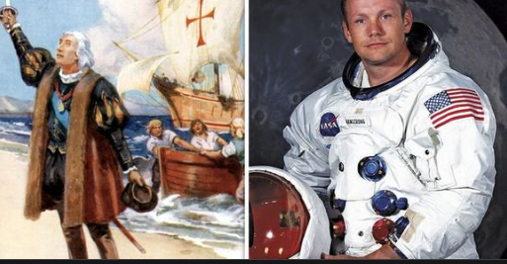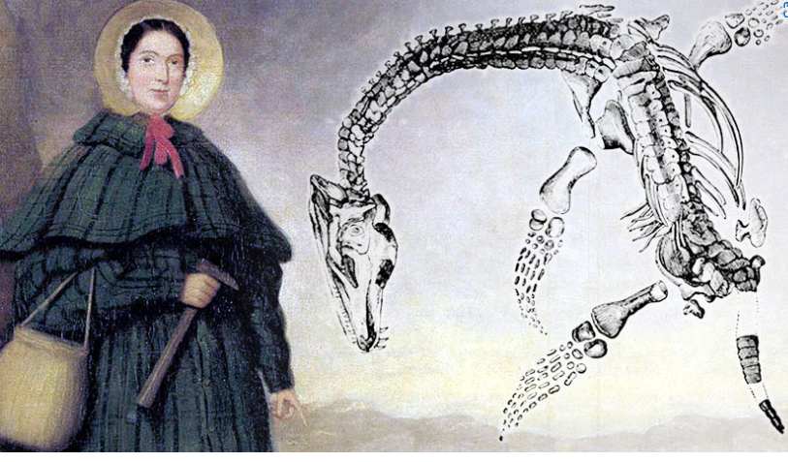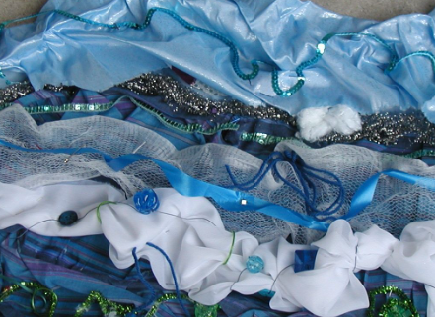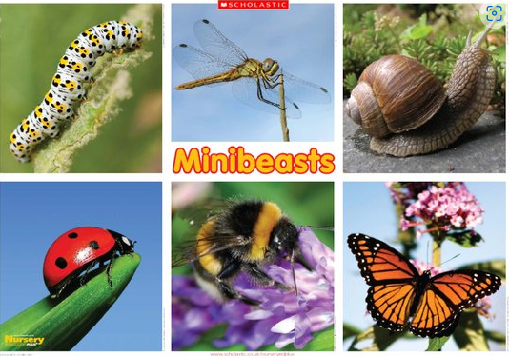

Key Vocabulary
Explorers – astronaut, sailor, palaeontologist
significant individuals
Ichthyosaur
England London
Scotland Edinburgh
Wales Cardiff
Northen Ireland Belfast
Cliff
Oceans (Atlantic, Pacific, Indian, Arctic)
Continent
Colonies
navigate
New World
Voyage
Apollo /Eagle
Santa Maria

insect
arachnid
head
thorax
abdomen
classify
habitat
adapt
vehicle
axis
chassis
evaluate
sprite
algorithm
Old Testament
New Testament
forgiveness

