Hornby St. Margaret’s Church of England Primary
Summer Term Planning (Years 1/2)

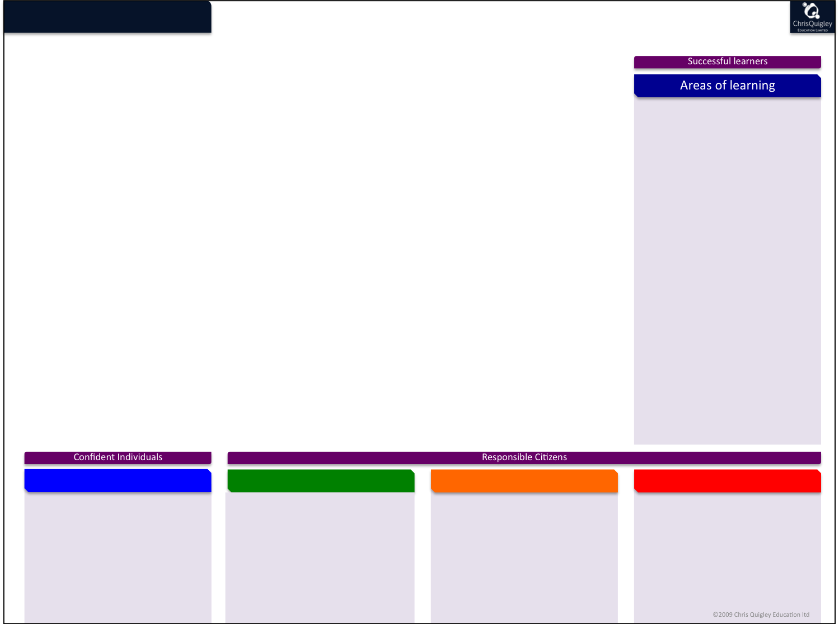
Beasts
clothe

(

As Scientists we will travel back in the time machine to look at the formation of planet Earth and to identify key factors important to life. We will have a visit from an alien who wants to find out what life is like on Planet Earth. We will group living things identifying similarities and differences to tell him, noting key habitats in our own locality. We will conduct a minibeast safari on our school grounds and classify which things are alive/dead/never been alive.
As Geographers we will use globes to look at what the Earth looked like when dinosaurs roamed around. We will look at the globe now and learn the names of oceans. We will also zoom in on the four countries that make up the UK, celebrate St. George’s Day and make an information leaflet.
As Historians we will travel back in time to answer a series of questions for Abigail the Archaeologist. We will explore prehistoric times to find out about food sources. We will look at lots of clues to find out why Mary Anning was a significant individual and what she found out .
As Technologists we will explore mechanisms in vehicles and build up to designing and making our own Jurassic Park Jeeps
As computing experts, we are going to use scratch to create our own computer landscapes and put together simple programs to direct our sprite around it.
In PSHE we will focus on building relationships with others.

Key Skills across the Curriculum
Taking Responsibility
Christian and British Values
Communities
We will explore: Research and note taking skills in our ‘Time Travel’ journals.
Writing labels and explanations for our Class Museum.
Writing letters to reply to Abigail the Archaeologists challenges and reading information to find out what Mary Anning discovered.
Counting and classifying minibeasts
Measuring materials to make our safari jeeps

Cr

As members of a community we will explore:
Local - Will consider the well being of minibeasts and animals in our community and how their habitats can be protected. Where fossils are found locally
National – Features and celebrations of the four countries of the UK. Where fossils are found nationally.
Global – We will look at artwork and multicultural Christianity. We will learn what the globe used to look like when dinosaurs roamed the earth.
In our Spiritual and Moral development we will explore:
Our class Christian Value – Kindness Proverbs 16:24 Kind words are like honey - sweet to the soul and healthy for the body.
This value in the context of other faiths and religions.
Discuss the importance of being Steward of the Earth. Looking after habitats in our local environment.
Learning about the four saints that are patrons of the four countries of the UK.

We will:
Take responsibility for using classroom equipment to help us with our learning
Take responsibility for working independently for short periods of time
Take responsibility for joining in with whole class sessions – suggesting ideas and listening/responding to others.

AH
