Hornby St. Margaret’s Church of England Primary
Spring Term 2 Planning (Years 1/2)


Try it on..... @(Clothes and Coverings)
clothe

(

As Scientists we will be taking advantage of the wet weather and investigating seasonal change. We will solve the problem of warning the Elves where there are big puddles in our playground. We will need to measure rainfall and record our observations on a map.
We will be continuing our investigations into materials. We will learn where cotton originates from and explore other natural materials. We will make an umbrella for the elves and a house for the Three Pigs to withstand wind and rain.
As Geographers we will explore the different clothes people wear in countries across the world, whilst learning the names of different continents. We will do a study of our local area and compare this with an area in Kenya.
As Historians we will learn about wash day in the past using Mrs Lather’s Laundry book. We will also explore clothes people wore in the past and sequence them chronologically.
As Artists we will experiment with different techniques to make a patch for Elmer’s new coat. We will use appliqué techniques, practise running stitch, weave and learn the craft of Batik in Asian and African styles.
As Computer Experts we will be learning how to program floor toys and how to keep safe online – Screen out the Mean.
In PSHE we will suggest ideas about how to care for our local environment

Key skills across the curriculum
Taking responsibility
Christian and British Values
Communities
Writing a fantasy narrative based on clothes and coverings.
Writing for our role play Clothes Shop and Elves and the Shoemaker House. (Labels, captions and information posters)
Making a cartoon strip information text about where cotton is from.
Handling data in Science and Geography local area study.

As members of a community we will explore:
Local: Easter events run locally, How we can care for our local environment.
National: Clothing for different cultures and special occasions
Global: How Easter is celebrated around the world.? Where materials come from?. Fairtrade materials. How a child in Kenya might dress.

We will explore:
Why Easter is so important for Christians
Stories Jesus Heard and what they tell us about God (Joseph’s coat, Moses, Jonah)
The value of patience and how we can show this in our school
The role of the Holy Spirit and Fruits of the Spirit

For which clothes to wear in the right season/weather
For being independent – dressing, fastening shoes and coats
For our own belongings
For our school environment and local area
For trying out different approaches if things do not work out the first time.

AH
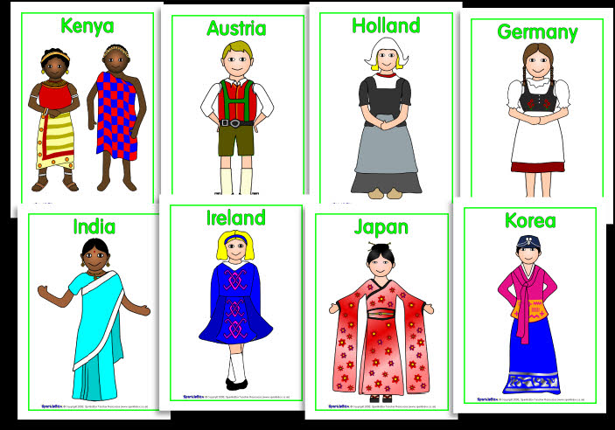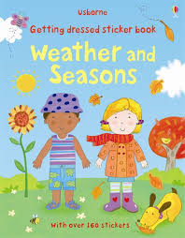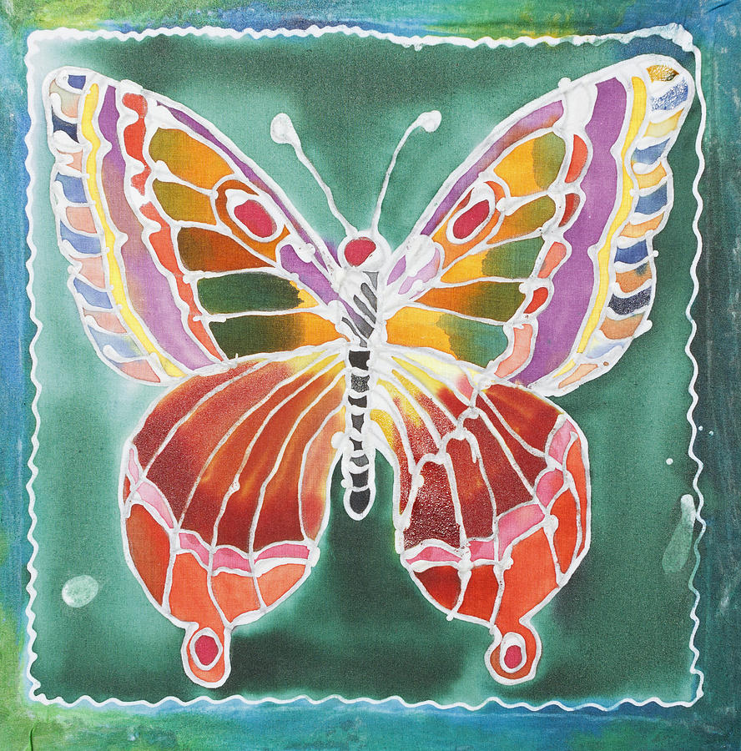
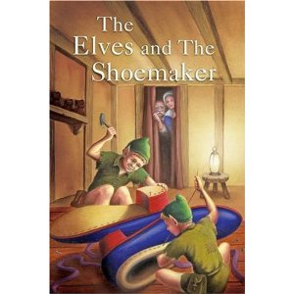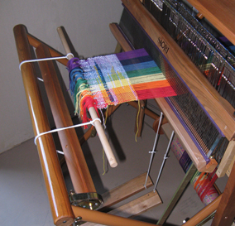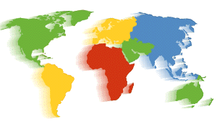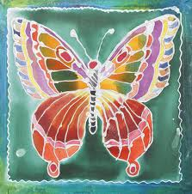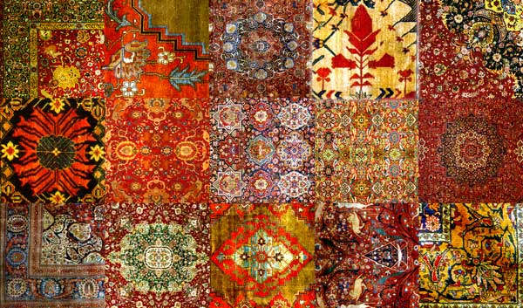
Clothes and Coverings

