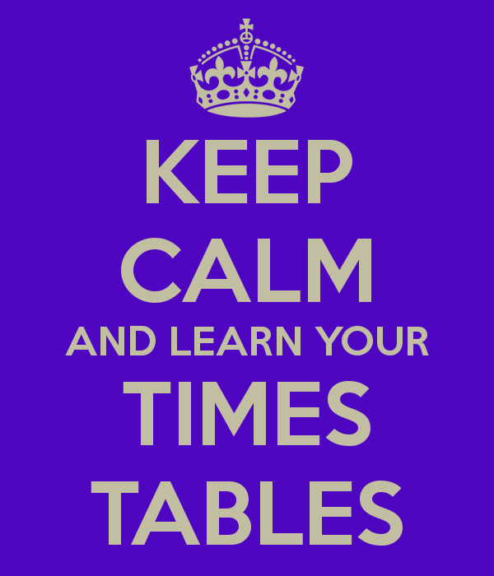

Multiplication and division

Year 3 and 4

During the 2nd half of the term we will start to look at written multiplication and division methods. This will include doubling and halving and also continued revision of the different times tables. Year 3 will be introduced to the grid method whilst Year 4’s will be working on this to secure their understanding from last year.

Shape and Time

Focus on 2D and 3D (Year 3) shape, length and perimeter. We will also revise time and solve problems involving time.

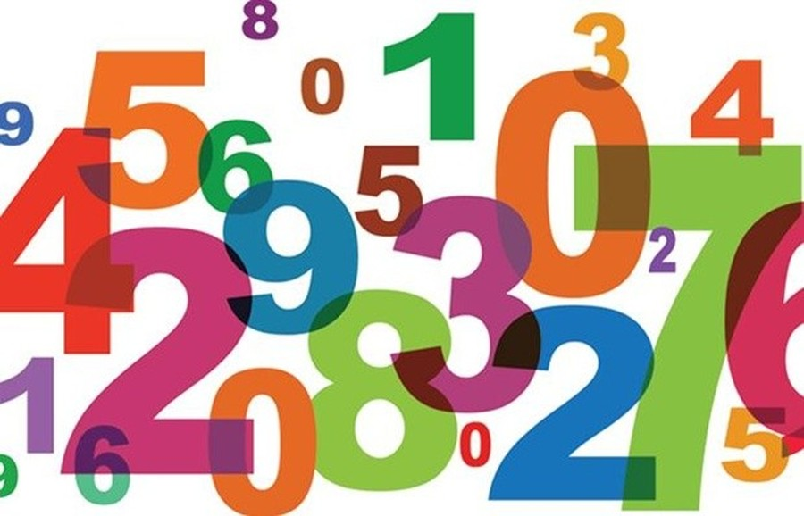

Times tables

Times tables knowledge comes into so many different problems, it is therefore important that your child knows their times tables off by heart. They do practise them every day in school but back up at home is essential too.

Lots and lots of word problems, reasoning and mastery!

This term we will be focusing on applying our knowledge of number to lots of different problems and investigations.

It is important that the children are able to apply this knowledge to different problems and investigations. There will be some for homework too!

Written and mental calculations and place value

Year 3 and 4

Initially, we will be focusing on place value. As the term progresses we will be focusing on written calculations. For some this will mean learning the expanded column method for the first time.

Mental Calculations

The children will be encouraged to work on their mental calculations as well as written, looking at different strategies they can use to become more efficient at mental calculations.

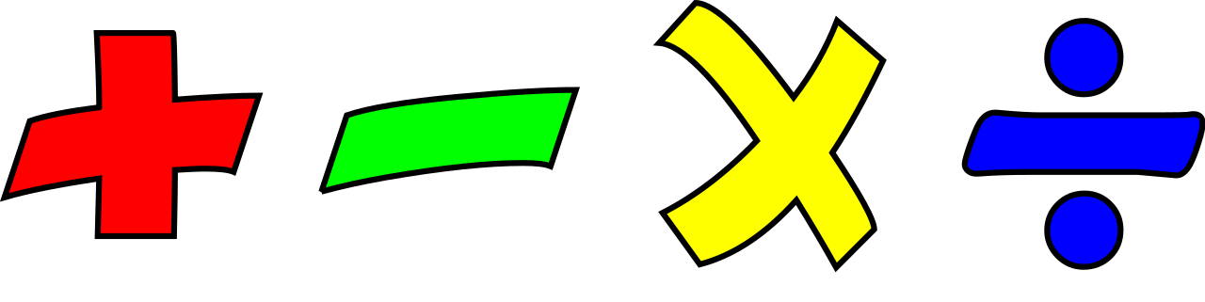

Extension work

The children work in different groups, if your child needs move on quicker or has understood the subject matter; they are challenged to solve further problems. This also means that if your child is struggling, I try not to move on too quickly.

Mrs Cook

Numeracy Autumn Term