LANCASHIRE COUNTY COUNCIL
CHILDREN AND YOUNG PEOPLES’ DIRECTORATE

MANAGING VIOLENCE AND AGGRESSION IN SCHOOLS: ADULTS

POLICY AND GUIDANCE

CONTENTS PAGE

 | Page No.
Policy

Policy Statement  Definition of violence | 3  3
Definition of terms | 6
Guidance

Policy aims | 8
Prevention

Risk assessment, prevention and protection | 10-12
Communication, co-operation and training | 12-13
Managing Incidents effectively

Reporting and recording | 13
Monitoring and evaluation | 15-16
Employee support | 16-17
Critical Incidents | 18
Other sources of information (school portal links) | 18
Legal framework | 29

MANAGING VIOLENCE AND AGGRESSION IN SCHOOLS BY ADULTS IN SCHOOLS

POLICY STATEMENT

1. Policy Statement
1.1 The Governing Body of Hornby St Margaret’s Primary School believe that all school staff have a right to expect that their school is a safe place in which to work and that prompt and appropriate action will be taken if they are subjected to abuse, threats or violence by parents and other adults on school premises and in exercising their duties off site.
1.2 For the purposes of applying the provisions of the policy and associated guidance, school staff includes volunteers.
1.3 This document sets out the whole school policy on managing violent or aggressive behaviour towards employees by adults including parents, visitors and trespassers.

1.4 This policy is published as part of this school’s health and safety policies. It has been produced after consultation between Lancashire County Council and employees through recognised Teacher Associations, Trade Unions, and the respective Diocesan Authorities.
1.5 The Governing Body accept the following definition of violence:
“Any incident, in which a person is abused, threatened or assaulted in circumstances relating to their work”.

This definition includes verbal abuse or threats as well as physical attacks (Health and Safety Executive).

2. Scope of the Policy

2.1 A separate policy applies to aggressive or violent behaviour on the part of children and young people.

2.2 This policy does not apply to allegations of Bullying or Harassment between employees. The Bullying and Harassment procedure is available at https://schoolsportal.lancsngfl.ac.uk/corporate/web/view_sp.asp?siteid=4311&pageid=19204&e=e

2.3 Should incidents of aggression or violence occur between employees the Disciplinary Procedure will apply. This is available at

https://schoolsportal.lancsngfl.ac.uk/sp_atoz/service.asp?u_id=2214&strSL=D

3. Roles and Responsibilities

3.1 The roles and responsibilities of the Governing Body, Head teacher and employees are set out below.

3.2 Governing Body:

3.2.1 The Governing Body are responsible for the implementation of this policy and ensuring it is operating effectively.

3.2.2 The Governing Body and Headteacher are committed to meeting their legal duties and obligations. They recognise their general duty to ensure, as far as is reasonably practicable, the health, safety and welfare of their employees and other members of the school community affected by the work they do. (Health and Safety at Work Act 1974 s2).

3.3 The Head teacher:

3.3.1 The Head teacher is responsible for the day-to-day implementation and management of the policy.

3.3.2 The Head teacher may delegate the lead role on day-to-day policy implementation and management of the policy to a nominated School Leader.

    - The Head teacher is also responsible for the following:

- Ensuring that suitable and sufficient risk assessments are carried out of employees’ risk of exposure to violence and aggression and that appropriate control measures are implemented.

- Making appropriate arrangements for incidents to be reported, recorded and investigated.

- Regular monitoring of the level and general nature of any incidents and the school’s response to them.

- The Head teacher will review the effectiveness of the policy including risk assessment, control measures and responses to incidents.

- Provision of appropriate training for employees and volunteers.

- An annual monitoring and evaluation report will be provided to the Governing Body by the Headteacher.

  - Employees:

3.4.1 Employees also have a responsibility to protect their own safety and that of their colleagues and anyone else who may be affected by the work they do.

3.4.2 Volunteers should follow school procedures.

    - Employees must contribute actively in hazard and risk assessment, and familiarise themselves with policies, guidelines, control measures, instructions and reporting procedures. They should also participate positively in appropriate training. Depending on their role, some employees may also have a legal responsibility to participate in appropriate training.

    - All incidents of violence and aggression (as defined at paragraph 1.5 above) must be reported, recorded and investigated. Appropriate action will be undertaken by the Head teacher with the aim of reducing the risk of a recurrence.

    - The Governing Body will support the right of any member of staff who has been subject to violence to report the incident to the police.

4. Support and Guidance

4.1 Access to Occupational Health will be available to employees who are faced with violence or aggression in the course of their employment. They will also be encouraged to contact their, Trade Union representative or Safety Representatives. An Occupational Health referral will be made to establish what further support can be provided to the employee.
4.2 Appropriate guidance will be made available to employees to enable them to deal with any incidents of violence or aggression. Employees will be given access to appropriate training and support by the Head teacher.

5. Policy review

5.1 This policy and associated guidance will be reviewed regularly by Lancashire County Council, Childrens' Services Authority (CSA). The Head teacher will provide an annual review report to the Governing body on the effectiveness of the policy and associated guidance.
MANAGING VIOLENCE AND AGGRESSION IN SCHOOLS BY ADULTS POLICY

DEFINITION OF TERMS

The following definitions apply to the policy on ‘Managing Violence and Aggression by Adults':

Volunteer: A person who is not an employee of the school who carries out work at the school on an unpaid basis.

Employee: A person who works at the school or setting under a contract of employment.

Trespasser: A person who has no lawful right to be on the premises of the school or, having come on to the premises lawfully, behaves in such a way as to cause a nuisance or disturbance.

School: References to school include community schools, voluntary-controlled schools, voluntary-aided schools, foundation schools, maintained special schools, maintained nursery schools, PRU's, maintained early years provision and Childrens' Centres with a Governing Body.

Child or young person: The “Managing Violence and Aggression by adults” policy does not apply to children or young people. A child or young person is defined as either:

(i) a pupil or student on the roll of the school or setting, or
(ii) a pupil or student from another educational establishment who is attending the school or setting by invitation in order to participate in education or school activities.

A child or young person who does not have a lawful reason to be on school premises is defined as a trespasser and as such is covered by the Managing Violence and Aggression in schools at Work by Adults policy.

GUIDANCE ON MANAGING VIOLENCE AND AGGRESSION IN SCHOOLS BY ADULTS

INTRODUCTION

The Governing Body believes that all members of the school community (including pupils, employees and volunteers) have a right to expect a safe school environment.

As part of the school’s ongoing commitment to employees’ health and safety, Governors have adopted the policy entitled ‘Managing Violence and Aggression in schools by Adults’ which is also available on-line at
https://schoolsportal.lancsngfl.ac.uk/corporate/web/view_sp.asp?siteid=4311&pageid=22041&e=e

This booklet practical guidance to Head teachers, Governors, employees and volunteers on dealing with violence and aggression by adults in the school context.
The aim is to provide a 'one-stop' shop approach to managing violence and aggression through the links to other related policies, proformas and guidance. A summary of those links is included at section 7 of this document.

A separate policy and guidance on ‘Managing Violence and Aggression’ by children and young people has also been adopted. This and accompanying guidance is available from the schools portal at
https://schoolsportal.lancsngfl.ac.uk/corporate/web/view_sp.asp?siteid=4311&pageid=22041&e=e

Where relevant, links to other related policies and guidance are provided in section seven of this guidance.

AIMS

The aims of the ‘Managing Violence and Aggression in schools by adults’ policy and this guidance are to:

- Prevent violence and aggression at school level as far as reasonably practicable Assist the Head teacher and Governing Body to implement the ‘Managing Violence and Aggression in schools by Adults’ policy;

- Assist the Head teacher and Governing Body to implement the ‘Managing Violence by Adults’ policy;

- Give guidance to all members of the school community so that they can contribute towards a safe school environment;

- Provide information about roles and responsibilities, the legal framework and good practice in this area;

- Encourage and facilitate incident reporting and recording;

- Define terminology.

PREVENTION OF VIOLENCE AND AGGRESSIONTO STAFF

The ‘Managing Violence and Aggression in schools by Adults’ policy’ adopts the HSE definition of violence, which includes any incident where an employee is abused, threatened or assaulted at work, thereby; endangering their safety, health, well-being or work performance.

It covers insults, threats and/or physical or verbal abuse by adults against a person at work, whether they are an employee or a volunteer. Violence to staff is an occupational health and safety issue and should be dealt with at school level.

Conflict that has not been resolved appropriately can escalate to violence. Workers in schools may find themselves to be victims of violence because aggressors see them as ‘representatives’ of the school.

Workers are more at risk of violence when their jobs involve:

- Dealing directly with pupils and/or their guardians
- Working late or alone
- Making off-site or home visits

Consequences of acts of violence for the individual include:

- Physical harm
- Stress
- Emotional trauma
- Feelings of powerlessness
- Demotivation

Consequences for the employer include:

- Higher staff turnover
- Increased absenteeism and sickness absence
- Low morale
- Difficulty in recruiting staff
- Higher insurance costs6

Risk assessment, prevention through control measures and minimising harm to staff after violent and/or aggressive incidents; are all essential elements of effective management of violence in schools. Though it is not necessary to be a legal expert to be able to put effective measures in place, a basic knowledge of the legal position will be helpful when identifying appropriate management measures.

An overview of Health and Safety and other relevant legislation is provided in Section three and at
https://schoolsportal.lancsngfl.ac.uk/corporate/web/view_sp.asp?siteid=3726&pageid=18222&e=e

RISK ASSESSMENT, PREVENTION AND PROTECTION

Risk Management Arrangements

The risk assessment process is the starting point for dealing with violence. It allows for the identification of potentially violent situations and leads schools to consider all aspects such as the environment, the situation itself, any background information which may be of assistance, the employee and any other individual(s) concerned. Once all this information is to hand, a strategy for dealing with a situation appropriately and keeping everyone safe can be developed.

Managing the risk of violence: key points

- Find out if you have a problem
- Decide what action to take
- Take action
- Check what you have done is working
- Provide feedback

Assessing the risk and reducing the potential for violence

There are precautionary and preventative steps that schools can take which help to avoid, prevent, minimise or mitigate incidents where staff can be subjected to violence or abuse. Talk to staff; they may have noticed things that are not immediately obvious. To assist in gathering accurate information it may be useful if staff complete a simple questionnaire. An example is given at

https://schoolsportal.lancsngfl.ac.uk/corporate/web/viewdoc.asp?id=36514

It is important to foster a security–conscious culture amongst all staff and pupils, maintaining a sense of proportion in relation to the assessed risk.

Step 1 – Look for the Hazards
You need to consider the elements which may contribute to the risk of violence and the effect they have on each other. Consider the following:

- What your staff actually do when they are at work
- Who they come into contact with, on and off site
          - The times when staff work including early mornings, late evenings, holidays,
          - weekends
- Staff working alone, in remote buildings, on sports fields or carrying out home
visits.
- Are your work instructions and procedures being communicated and followed?
- Are all staff made aware of any changes and procedures in working practices?
- Do your accident/incident records reflect a true picture?
- Are there security/access restrictions of the premises?
- Do you identify potential assailants?

Step 2 – Who might be harmed and how?
If this part of the assessment is to be of practical value you need to identify all the groups of employees who might be affected. It is not simply a matter of saying all those that have direct contact with parents. Consider the following:

- Specific teaching staff for example PE teachers, site supervisor, cleaners, kitchen staff, welfare assistants, receptionists, extended school staff.
- Lone or remote working, early or late shifts, home visits, parents evenings, cash handling, one to one meetings with parents and guardians, level of training provided.

Step 3 – Evaluate the risk and your Existing Precautions
The most effective precaution is to avoid risks altogether. Obviously this is not always possible therefore you need to consider what you need to do to reduce and minimise the risk. When considering the likelihood and severity of harm, think about the most serious risks and those that affect the most people first.

- Do you need to change the way people carry out their duties or where they work?
- Have you taken account of the site layout and the knowledge of the surrounding area?
- How is the site and buildings used by others?
- Incident recording and response to incidents
- Do you have any information, reports, involvement with the police?
- What information is provided for staff, how is it communicated?
- Is the right level of training provided to relevant employees including managers?

Step 4 - Record your findings – Take action to minimise the risk
The main (significant) findings of the risk assessment must be recorded and where necessary written work procedures and instructions provided for staff. The assessment should include:

- High risk groups, individuals, activities and areas
- Existing preventative measures and evaluation of the remaining risks
- Additional preventative and control measures identified, including timescales
- Communication procedures and review arrangements

Step 5 - Monitor, Review and update the assessment
It is important to establish the assessment as a continuous two-way communication process between persons at risk and managers controlling the risks. This will help to promote regular review to ensure precautions are kept up to date.

Monitoring is about making sure your procedures are being followed and are effective. Where possible involve new people in the review process as they will be able to provide observations from a different perspective. The written assessment, control measures, safe working practices and procedures must be reviewed following significant changes for example legislation, building/site makeup, work activities and incidents.

Step 6 - Draw up an action plan
The action plan should be monitored by the Head teacher, School Leaders and Governors to ensure that all items identified have sufficient resources allocated and have been addressed. The plan should include the following:

- Action required,
- Action by whom
- Risk priority
- Projected timescales
- Date completed

See guidance on completion of risk assessments at https://schoolsportal.lancsngfl.ac.uk/sp_atoz/service.asp?u_id=2120&strSL=R

Further examples of risk assessment forms are available at https://schoolsportal.lancsngfl.ac.uk/corporate/web/viewdoc.asp?id=39626

COMMUNICATION, CO-OPERATION AND TRAINING

Communication

Managers need to show through their behaviour that they take the risks seriously. Managers and employees need to ensure that there is effective communication about risk assessments, control measures, potential assailants and hazardous situations.

Co-operation

The effective co-operation of all employees can best be achieved by fully involving them and their representatives in assessments and discussions on the nature of risks, control measures and review. Co-operation is particularly important in relation to the reporting and recording system for violent incidents. If employees are not consulted about the system it is likely to fall into disuse resulting in inaccurate statistics and potentially inadequate control measures. Some employees may accept too easily risks which they see as part of their job; they may co-operate more readily if they see that this will help reduce the risk to others.

Staff Training

Levels of competency, including such things as interpersonal skills required for particular staff groups, should be determined during the risk assessment and appropriate training given where necessary. Competence needs to be considered for example at the point of recruitment, placement, change of job/duty and employment of supply staff.

Employees who may be exposed to violence need to be aware of the risks they face and be capable of recognising the potential danger either to themselves or to others within the school. Consider all employees who may be affected such as; teachers, administrative staff, lunchtime welfare, cleaners, site supervisor and technicians.

Head teachers and school leaders should identify appropriate training dependent upon the level of foreseeable risk of violence and aggression. Induction should always include the arrangements in place to prevent and deal with incidents of potential violence and aggression. In many cases the risk to staff may be low and basic in-house information and instruction at team meetings, or tool box talks, may be all that is required.

A staff training programme could include:

• School policy and safe working procedures for dealing with violence (induction)
• Risk assessments and signposting employees to them.
• Safe working practices
• Causes of violent and aggressive behaviour and measures to avoid this
• What to do when feeling threatened with violence;
  - Managing confrontation by using positive interpersonal skills;
  - Attracting the attention of colleagues;
  - How to use security equipment such as alarms
  - Post-incident action: reporting, recording, investigation, support and referral to Occupational Health Unit to assess what additional support can be provided.
  - Refresher training should be provided at regular intervals.

MANAGING INCIDENTS EFFECTIVELY
REPORTING AND RECORDING

Recording and reporting incidents involving abuse, threats or violence to members of staff is important because it can enable Lancashire County Council, schools and employees to:

- Meet their statutory duties in compliance with the Health and Safety at Work Act 1974 and associated Regulations, the Reporting of Injuries, Diseases and Dangerous Occurrences Regulations (RIDDOR) and Social Security Regulations.
- Inform policy reviews and future risk assessments.
- Assist the School's insurers if a claim for compensation is made.
- Collect evidence which is necessary if proceedings are brought against an alleged assailant.

Guidance on reporting accidents, accident prevention and management action following accidents/incidents’ sets out guidance in this area. This document is available at

https://schoolsportal.lancsngfl.ac.uk/corporate/web/view_sp.asp?siteid=3726&pageid=15043&e=e

Incident Reporting, Investigation and follow up

The development and implementation of reporting procedures are among the essential steps in the planning process to deal with workplace violence. This is an avenue through which employees can report incidents of violence, and management’s support of the process and encouragement for reporting incidents is vital so that appropriate support can be provided and any corrective action can be taken.

It is recognised that individuals will have a different opinion on what is deemed unacceptable behaviour and what would require reporting, however the effect of that behaviour on colleagues should be considered and for the sake of consistency it should be agreed with employees what is reportable. By recording what is perceived as ‘minor’ incidents of violence management has the opportunity to take action and prevent any further escalation of violence. The process of recording and classifying incidents of violence can help to further tailor and improve preventative measures by highlighting important patterns and trends.

It is important that the school determine who will investigate reports of violence and provide them with the necessary skills.

- An Oracle report should be completed as soon as possible after the violent/ abusive event. A record should also be made in the school’s serious incident book. Detailed guidance on the RIDDOR Regulations and on completing an Oracle report are available here:
https://schoolsportal.lancsngfl.ac.uk/corporate/web/view_sp.asp?siteid=3726&pageid=15043&e=e

- Complaints and reports should be investigated swiftly (and confidentially where appropriate)
- Details should be recorded of what happened, who was involved, what triggered the incident, place, conditions, time of day and witnesses
- Witness statements should be collected as soon as possible by the manager investigating the accident.
- The Head teacher/school leaders must investigate the underlying causes of the incident and record remedial actions required to minimise and control the risks.
- The role of recognised Trade Union health and safety representatives includes carrying out investigations.
- Investigations must not be looking to assign blame but to learn from an incident how to improve the response if it occurs again and prevent a situation escalating into abuse or violence
- Staff must be instructed in any changes made to safety systems and procedures
- Management must check that new procedures have been implemented, are being followed and are effective.

Reporting serious assaults to the police

In circumstances where an employee is physically assaulted the Governing Body will provide all reasonable steps to provide advice, support and assistance to employees assaulted in the course of their employment. However, where an employee is the subject of an assault in the course of employment, the Governing Body or the Childrens' Services Authority do not have an automatic liability to the employee.

The employee may report the case to the Police who may take proceedings or the employee personally may take either criminal or civil proceedings. In that case, the school or employee may apply to the Authority for consideration of support with funding towards the cost of a private prosecution. Any such payments will be solely at the discretion of the Authority.

If considerable injury is suffered, compensation may be payable by the Criminal Injuries Compensation Authority and all such cases should be reported to the Police by the employee if they wish to apply to the CICA for compensation. It is also the right of the employee not to report the matter to the police. However, in some circumstances, the school may have no option but to report such a matter to the police to fulfil their health and safety responsibilities.

Monitoring, Review and Evaluation

Monitoring
Schools should monitor the effect of methods used to control violence and aggression to find out how successful they have been. They can then identify strategies that are not working, or which have unforeseen consequences, and modify or replace them.

Active monitoring involves checking that systems and procedures are working without waiting until something goes wrong.

Reactive monitoring involves looking at incidents after the event and sickness absence analysis. It depends on an effective system of reporting and recording incidents and ill health.

It is only through analysing information on incidents that patterns can be detected and strategies developed to manage unexpected situations.

Monitoring is only effective if those involved understand what is expected of them. Therefore procedures need to identify clearly what is to be monitored, by whom and how often.

Review
A review process works best if it is part of the day-to-day management of health and safety and should also take forward the results of the monitoring described above.

Reports by the head teacher, safety representatives, safety committee and staff training records may provide useful information. The Management of Health and Safety at Work Regulations require risk assessments to be reviewed when they may no longer be valid, when circumstances change significantly and when change is planned. The overall review process helps identify any need for changes in risk assessments and associated procedures.

Evaluation
The school’s Health and Safety policy states that a head teacher monitoring and evaluation report will be provided to the Governing Body on an annual basis. It will be for each head teacher to determine the structure of the report but as a general guide the report could include information about:

- An overview of the areas for which risk assessments have been carried out.
- Results of employee questionnaires
      - Details of control measures which have been put in place to safeguard employees.
- Statistical information from monitoring systems and procedures, reporting and recording of incidents.
- Training which has been provided and an evaluation of how effective this has been.
- Planned actions.
- Information contained within the report should maintain the confidentiality of individual employees who should not be identified.

STEPS TO TAKE AFTER AN INCIDENT

Supporting Employees after an Incident

Employees harmed physically or psychologically by violence may need support. Experience has shown that the immediate care and concern of managers and colleagues is much appreciated and may limit or prevent any serious long-term effects.

The support framework needs to be flexible to respond to the needs of the particular situation and should recognise that actual physical assault is not only traumatic for the victim but can also affect close colleagues.

Post incident procedures

First and foremost the affected person/s must be supported. Later, but as soon as possible, staff should be encouraged to begin the post –incident procedures.

These procedures include:

The employee should be relieved of any duties for a length of time appropriate to the nature and severity of the effects of the assault. Consideration should also be given to an OHU referral where appropriate.

- Where an employee suffers shock or injury, first aid should be administered and, if necessary, the employee guided to seek professional medical treatment.
- Deciding whether or not to involve the police. In most cases of assault and injury the involvement of the police is a prerequisite of any eligibility for Criminal Injuries Compensation.
  - Completion of the Oracle incident report.
  - Sensitive debriefing of the incident. Staff are sometimes brought together soon after a violent incident to discuss what happened. The process of debriefing may have two functions to; establish the details of what happened and to provide emotional help. If the police have been notified then care must be taken not to impede a police investigation.
- Reminding employees they can seek the support and advice of their professional association/trade union.
- The employee who has been assaulted should provide details of the damage suffered including if appropriate a Doctor's statement of injuries, and where possible the cost of repair to personal effects. Where the employee can show that the CSA or the Governing Body are legally liable to compensate them for damage to their personal effects, they may be eligible to receive a payment under the County Council's ex gratia payments scheme subject to any conditions applying to the scheme at the time of application.
- The Head teacher will notify the Authority (through the Oracle system) of any incidents of assault on employees so that the County Council's Insurers can be notified. Failure to notify the insurers at the outset could present difficulties with any subsequent claim made by the employee. As an initial notification, a copy of form HS1 Accident/Incident Record must be sent direct to the Director of Resources with the original form being sent to the Health and Safety Team in the usual way.
- Where it is considered that the injuries suffered may result in a valid claim under the scheme, the school or the employee will obtain a claim form from the County Council's finance department for return to them after completion.

- If any implement or weapon has been used in an attack this should be retained by the Head teacher provided that this can be done without difficulty or risk and provided that the Police do not require the implement or weapon.

Post incident practices: Types of support

The following identifies the type of support/action which may be required following violent incidents (this list is not exhaustive and not all items will be appropriate in all cases):

- Encourage the employee to seek medical attention or attend hospital.
- Look after the employee’s belongings including their vehicle if they leave them behind.
- Contact the employee’s relatives or friends.
- Acknowledge that the employee has experienced an extreme event and establish appropriate arrangements to allow them to talk about it in school including during a private meeting where they are encouraged to recount the events from a personal perspective.
- Acknowledge and respect the employee’s feelings whether this is anger, fear, resentment or guilt.
- A referral to Occupational Health should be considered to obtain independent medical advice and establish what support may be available for the employee.
- Assault/serious injury suffered by a teacher during the course of his/her duty will be regarded as an industrial injury, subject to independent medical advice from Occupational health. Where an industrial injury has been sustained, the employee has an automatic entitlement to full pay for a maximum period of six months followed by the employee's entitlement to normal sick pay.
- Consider and consult the employee on whether a change to work patterns is appropriate for those employees who may be constantly exposed to violence and abuse.
- Demonstrate a team/shared concern for the employee’s welfare.
- Be aware of any need for ‘time out’, either away from the scene of the incident or perpetrator involved.
- Maintain support if the employee is absent from work in accordance with the school's adopted Absence Management policy.
- Take a lead from the employee concerned as to how they can best be helped to recover and return to normal functioning.
- Monitor employee wellbeing. http://lancashire.gov.uk/education/wellbeing
- Record any action taken.

Employee Welfare and Counselling Service

The affects of violence and aggression can be severe, some people cope more easily than others and some victims may experience emotional ill-health, such as post traumatic stress.

Where management support is unable to address the victims’ emotional concerns there is a need to seek expert advice. It is recommended that a referral is made to Occupational Health to establish what support can be provided.

Critical incidents

Further advice on critical incidents can be obtained from the Critical Incidents website at https://schoolsportal.lancsngfl.ac.uk/sp_atoz/service.asp?u_id=2123&strSL=C

Publicity

Advice on how to deal with publicity can be obtained from the Corporate Communications team at County Hall.

https://schoolsportal.lancsngfl.ac.uk/sp_atoz/service.asp?u_id=2407&strSL=P

The Role of the Police

It is essential to develop and maintain good links with the local police and establish and understand each others working methods, responsibilities, constraints and expectations including police response times in the event of an incident. Every area should have a community beat officer who will work with your school. Further details can be obtained from your local police station.

LINKS TO ASSOCIATED POLICIES AND GUIDANCE

Health And Safety Policy  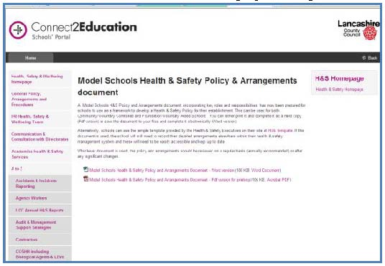 | All schools should have adopted Health and Safety policy. The Health and Safety policies have been commended to community and voluntary schools are available at  https://schoolsportal.lancsngfl.ac.uk/view_sp.asp?siteid=3726&pageid=16526&e=e

Teachers Handbook  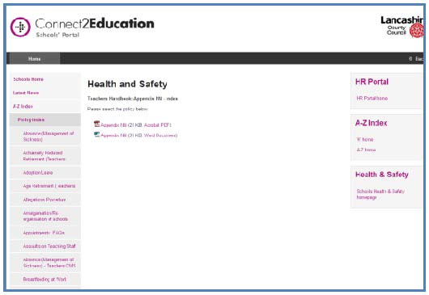 | Guidance on the statutory responsibility available at  https://schoolsportal.lancsngfl.ac.uk/view_sp.asp?siteid=4311&pageid=19433&e=e
Health and Safety general duties  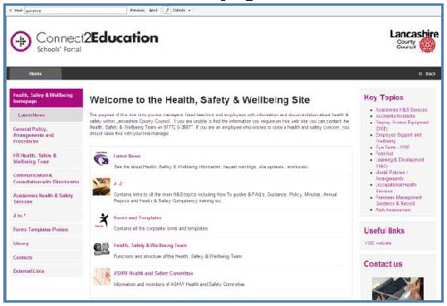 | Further guidance on general health and safety management responsibilities is available at  https://schoolsportal.lancsngfl.ac.uk/corporate/web/view_sp.asp?siteid=3726&pageid=18222&e=e
Risk Assessment comprehensive guidance  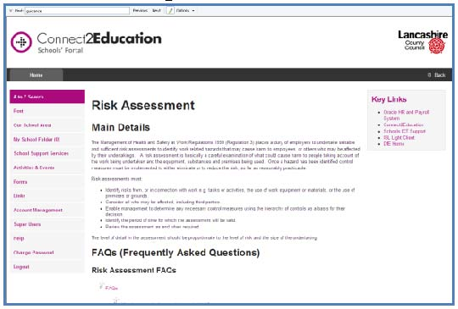 | The Health and Safety team have developed comprehensive guidance and forms for your use when conducting risk assessments. Very useful link at https://schoolsportal.lancsngfl.ac.uk/sp_atoz/service.asp?u_id=2120&strSL=R
Risk assessment form  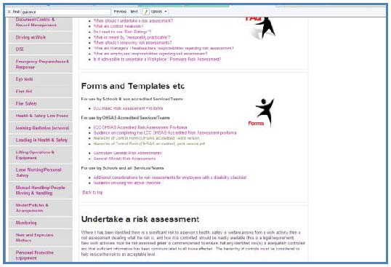 | This link takes you to Risk Assessment forms and general guidance.  https://schoolsportal.lancsngfl.ac.uk/corporate/web/view_sp.asp?siteid=3726&pageid=16069&e=e  To see a read only version of the risk assessment form click on the link below  https://schoolsportal.lancsngfl.ac.uk/corporate/web/viewdoc.asp?id=28273

Guidance on security in schools  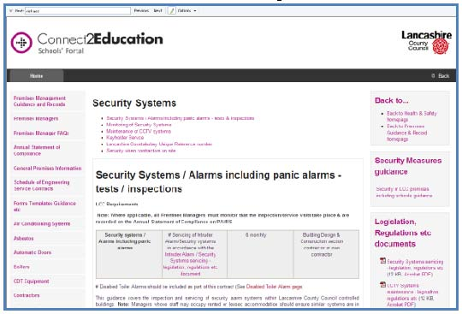 | Guidance on security in schools is available at  https://schoolsportal.lancsngfl.ac.uk/corporate/web/view_sp.asp?siteid=3492&pageid=9837&e=e
Lone Working Guidance  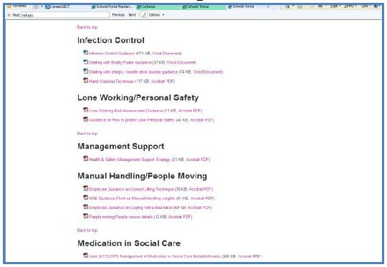 | This guidance will assist you to fulfil your responsibilities towards those staff who work alone for part or all of their working week.  https://schoolsportal.lancsngfl.ac.uk/corporate/web/view_sp.asp?siteid=3726&pageid=15764&e=e
Assaults: Guidance  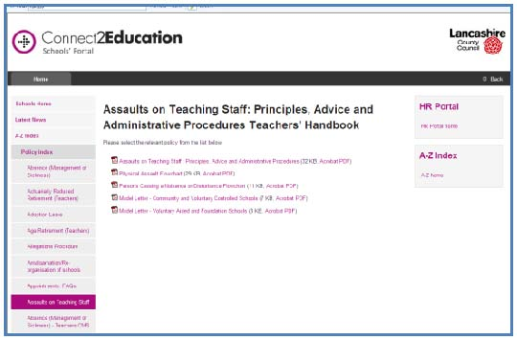 | If any employee is assaulted, this guidance will take you through the steps you need to follow. Support for employees is also covered.  https://schoolsportal.lancsngfl.ac.uk/corporate/web/view_sp.asp?siteid=4311&pageid=19187&e=e
Incident Reporting  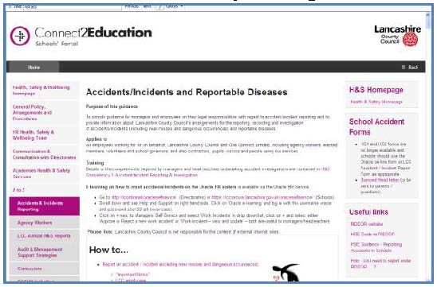 | Incident reporting is not only important but a key critical aspect of health and safety responsibilities in relation to violence at work. You will find guidance and incident report forms at  https://schoolsportal.lancsngfl.ac.uk/corporate/web/view_sp.asp?siteid=3726&pageid=15043&e=e

Cyberbullying  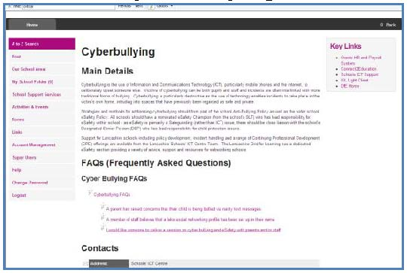 | In these technological times, cyberbullying can apply to children and to employees.  This link offers advice on cyberbullying.  https://schoolsportal.lancsngfl.ac.uk/sp_atoz/service.asp?u_id=2567&strSL=C
Children's Safeguarding Board  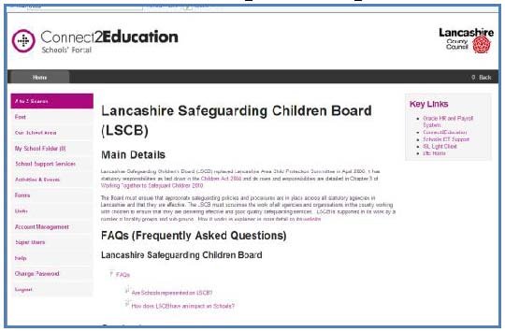 | This link takes you to information on children's safeguarding.  https://schoolsportal.lancsngfl.ac.uk/sp_atoz/service.asp?u_id=2205&strSL=S
Training provision  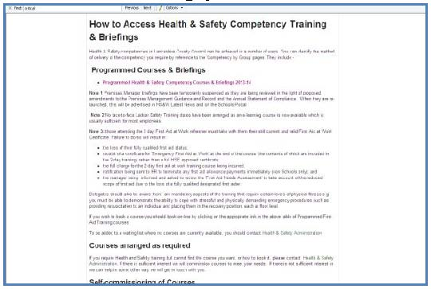 | For details of Health and Safety training see https://schoolsportal.lancsngfl.ac.uk/view_sp.asp?siteid=5186&pageid=27142#anchor125729
Well Being programme  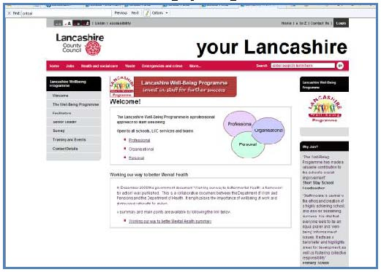 | The Well Being programme provides schools with an innovative approach to fostering employees’ well being. Further details of the scheme are available at  http://www.lancashire.gov.uk/education/wellbeing/

Useful websites  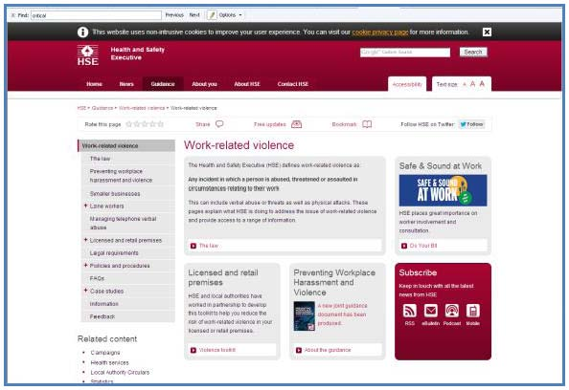 | General information on work-related violence and the legal position is available from the Health and Safety Executive website. http://www.hse.gov.uk/violence/index.htm  Recognised professional associations and trade unions publish information on violence in the workplace.  http://www.nasuwt.org.uk/  http://www.teachers.org.uk/  http://www.atl.org.uk/  http://www.naht.org.uk/  http://www.unison.org.uk/  http://www.gmbunion.org/
School exclusions  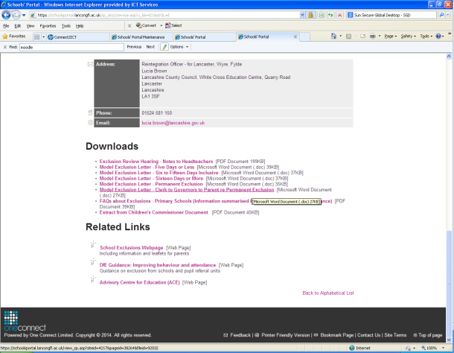 | Guidance for schools on exclusion of pupils is available at:  https://schoolsportal.lancsngfl.ac.uk/sp_atoz/service.asp?u_id=421&strSL=E
Secondary National Strategy  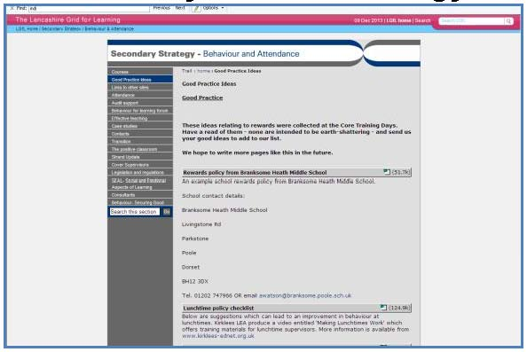 | This link takes you to the school portal page on the Secondary National Strategy. Links are listed to external sites which provide useful information on behaviour management.  http://www.lancsngfl.ac.uk/nationalstrategy/ks3/behaveattend/index.php?category_id=10
SIMS behaviour management  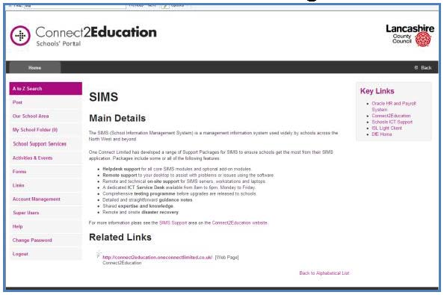 | SIMS has been extended to include recording behaviour management activity in schools. See the link below:  https://schoolsportal.lancsngfl.ac.uk/sp_atoz/service.asp?u_id=2428&strSL=S

