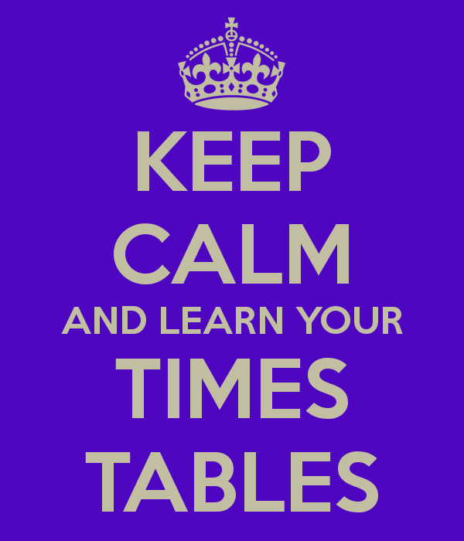

Times tables

Times tables knowledge comes into so many different problems, it is therefore important that your child knows their times tables off by heart. They do practice them every day in school but back up at home is essential too.

Addition and place value

Adding 2 and 3 digit numbers, understanding the place value of the numbers and positioning them on a numberline. The application of this understanding of number is an important part of the children’s learning. To do this the children will need to use the inverse to solve problems, round numbers and choose the right operation to solve a problem.

This will also be linked to measures and money. Measuring accurately, ordering numbers and decimal numbers.

All children will be expected to apply their knowledge both independently and with support. They will be assessed regularly and their learning extended depending on their learning needs.

Multiplication

Understanding their times tables here is imperative. The children will be asked to quickly recall their times tables and apply their understanding to larger sums e.g 4 x 5 = 20, so 40 x 5 = 200.

They will use the grid method to solve larger multiplication problems and will times by 10 and 100. Moving into decimal numbers and extending their understanding of place value.

As with all the other sections the children will be assessed regularly and moved on with their learning if necessary. It is important that your children try their best to apply the knowledge they have learnt, the classroom must be a partnership between teacher and child. Everyone is asked to put in 100% effort.

Subtraction

Subtracting 2 and 3 digit numbers, understanding different vocabulary for subtraction and solving problems will all feature here. Subtracting near multiples of 10 and using different strategies to solve take away sums. For example, they might choose counting on, a numberline or column (expanded) subtraction depending on the problem.

Part of securing their knowledge will involve applying their understanding to problems.

Division/fractions

Understanding division is the inverse of division is essential here. The children start off using a more visual image of grouping and move gradually onto larger numbers, which involves using the bus stop method to solve problems.

Year 3 / 4 Plans - Mrs Cook

Numeracy Spring Term